ENC 1
TO ATH/MAR/1
Dated 31 Oct 12

Completion Instructions: New Booking Request Form

- Complete a Separate New Booking Request Form for each booking.

- Complete all appropriate boxes at the top of the form.

- Complete contact details for the person who is requesting accommodation. If the requester is of a rank lower than WO2, then the sponsor section must be completed. In the event of more than one guest i.e. sports team or course, also include details of the Sponsor (person responsible) for the group during their stay.

- Complete Garrison and Location note CABS only run accommodation at Aldershot, Larkhill and Warminster.

- Enter the number of male & female or block booking beds required.

- If the departure date is unknown, due to the fact of posting then select ‘Yes’ in the ‘Long Term Booking’ box.

- Standard Bookings:

- For each guest, complete:
- Gender: Male or female
- Number: Service number (if civilian – staff/employee number)
- Rank/Location Type:
- Name: Title + First Name + Last Name
- AGE: Under 16 or Under 18 Yrs: Y or N
- Arrival Time (approximate)
- UIN Numbers

- Block Bookings:

- No guest details are required – leave this section blank

- Ensure you save the file using Save As….and enter a new name so that you do not overwrite the original.

- Email, fax or post to the CABS office.

ENC 2
To ATH/MAR/1
Dated 31 Oct 12
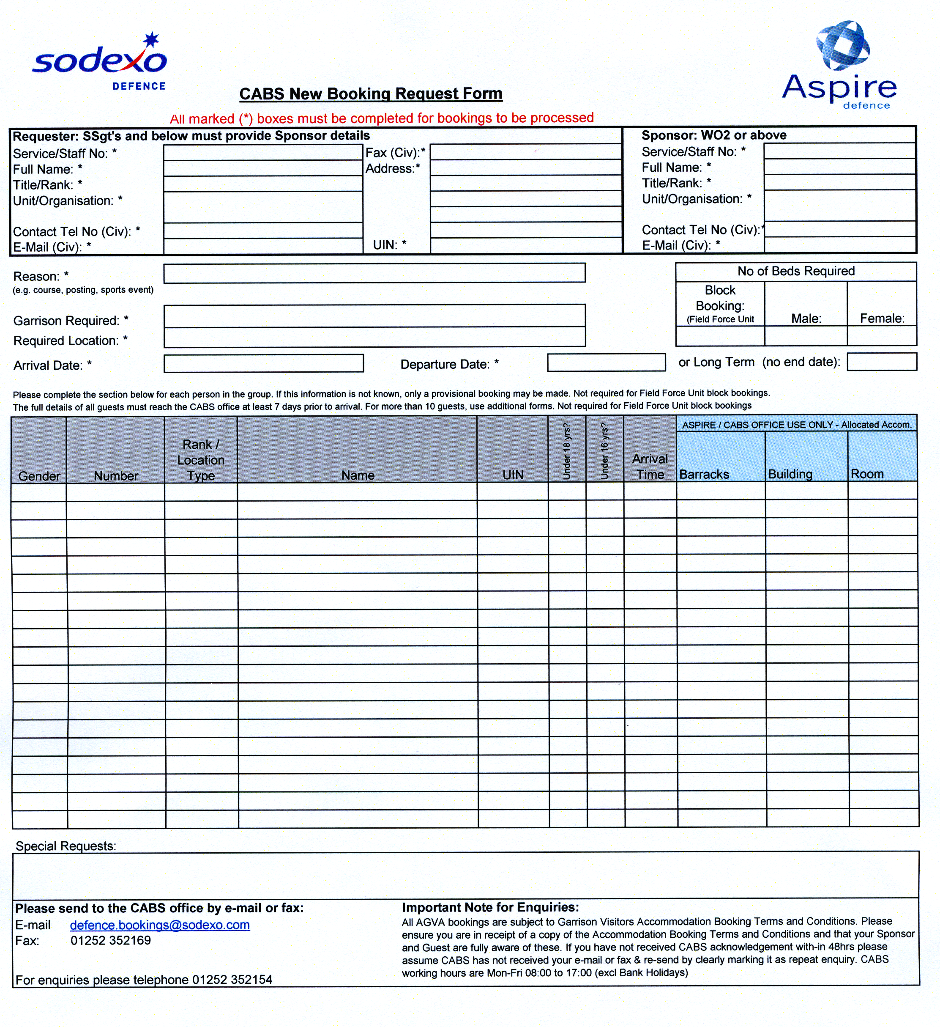


ENC 3
To ATH/MAR/1
Dated 31 Oct 12

Aldershot Garrison Visitors’ Accommodation
Information & Frequently Asked Questions
Ensure the booking sponsor and room user are aware of this information

Alcohol – The consumption of alcohol is not permitted within Aldershot Garrison Visitors’ Accommodation.

Bedding pack – The linen in each room will consist of
  - Sheet x 1
  - Pillow slips x 2
  - Duvet cover x 1

All linen will be left at the head of the bed to allow room users to make up their own beds. On departure all beds should be stripped and soiled linen left at the foot of the bed for collection.

Bookings – To make a reservation in the Aldershot Garrison Visitors’ Accommodation please contact the CABS (central accommodation booking system) Team on 01252 352154

- Car parking: Car parking at St Omer is limited and allocated is on a first come, first served basis. All car users requiring access to St Omer need to request a car parking permit from the St Omer Guard room. Groups, should where possible, arrive in coaches or mini-buses.

- Certificate of unavailability – A certificate of unavailability will only be issued if there is no Garrison Visitors’ Accommodation or other suitable accommodation available on site.

- Check-in: On arrival, the room users’ room will be available from 15:00hrs. If room users plan to arrive after 19:00hrs they must advise the AGVA on 01252 348443, at time of booking, so that plans can be made for their late arrival.

- Check-out: All rooms are to be vacated no later than 09:00hrs.

- Cleaning – Room users are responsible for the cleanliness of their room during their stay. Weekly room cleaning can be requested, if the stay is longer than one week, by contacting the Garrison Visitors’ Accommodation Reception. Linen will be changed weekly if soiled linen is left outside the room.

- Cooking – No cooking is permitted within individual rooms and no hobs or fryers are permitted within the Garrison Visitors’ Accommodation. A microwave and fridge are supplied within the shared kitchenette facilities.

- Food Requirements – If room users require feeding whilst staying in Garrison Visitors’ Accommodation, or have any special dietary requirements, this should be discussed with the Service Manager on 01252 348 556 to allow the necessary arrangements to be made.

- Furniture – No furniture is to be removed from any room. Any items removed from rooms will be logged as barrack damage and a charge issued.

- Health and Safety – All room users are to make themselves aware of their health and safety responsibilities and adhere to these at all times during their stay.

- Hotels – The CABS team are not responsible for booking hotel or non-Military accommodation.

- Keys - All rooms are lockable and keys are issued when room user registers. Keys must be returned to reception on departure. Any unreturned keys will be logged as barrack damage and a replacement charge raised against the Booking Sponsor.

- Late arrivals - Arrivals after 19:00hrs and on Saturdays will be checked in at the St Omer Guard Room. If a room user knows that they will arrive outside the reception opening times and have not booked in as a late arrival they should contact reception to advise on 01252 348443.

- Map 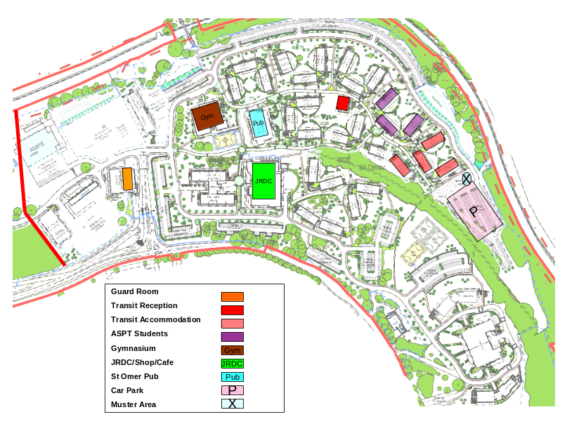

- March in – All room users are required to complete a registration form on arrival providing their contact details, purpose of visit and residential details. All rooms to be checked on arrival and issues reported back, on the march in form, to the reception within 15 minutes of receipt of room key. For march in during out of hours the march in form is to be posted into the key return box within the block.

- March Out – All personal items and effects must be removed from the room on departure by 09:00hrs. The room to be left in a tidy state, with beds stripped and linen left at the foot of the bed. A march out form to be completed by all room users on departure to capture any defects or barrack damage and returned to the Garrison Visitors’ Accommodation Reception. For out of hours departures the completed march out for is to be posted into the key return box within the block

- Meal Arrangements: Meals are served in The JRDC
  - Breakfast 0630 – 0800 (weekends 0800 – 0900)
  - Lunch 1200 - 1315
  - Dinner 1700 – 1745

  - Officers, WOs and SNCOs may make arrangements with the Garrison Officers’ Mess or Garrison WOs and Sergeants’ Mess for messing.

- Mess Billing – Garrison Visitors’ Accommodation will not issue a mess bill for accommodation. Where meals are taken in the Garrison Officers’, WOs or Sergeants’ Mess a mess bill will be raised by the Mess and must be paid prior to departure.

- Non-MoD guests – Garrison Visitors’ Accommodation is not available to any non-MoD individuals. Any non-MoD personnel wishing to stay as part of a military group are required to make separate arrangements outside of St Omer.

- Out of hours assistance – for emergency or immediate assistance room users should contact the St Omer Guardroom who can direct room as required. For maintenance or cleaning requirements room users should contact the Aspire Defence Helpdesk.
- Pay as You Dine (PAYD) – Pay as You Dine facilities are not currently available within St Omer.
- Pets: No pets are permitted in Garrison Visitors’ Accommodation

- Portable Appliances – All portable electrical appliances must have a valid, in date, portable appliance test sticker attached to the appliance.

- Pub: The St Omer Pub is out of bounds to all visiting Officers, WOs and SNCOs, however the appropriate Garrison Messes welcome visitor patronage.

- Public Areas: Public areas are for the use of all room users and should be maintained to ensure fellow room users are free to make use of them too.

- Re-active requirements: - If the room user requires assistance, either emergency, maintenance or housekeeping they should contact the appropriate telephone number advised at check-in and published within the accommodation block.

- Reception Opening Times – Reception will be open:
  - 07:00hrs – 10:00hrs and 15:00hrs – 19:00hrs Monday – Friday
  - 15:00hrs – 19:00hrs on Sundays.
  - No reception service will be available on Saturdays.
  - Reception Telephone No. 01252 348443
- Responsibilities – The room user is responsible for the room and facilities during their stay and their own and fellow guest’s health and safety. The Booking Sponsor is responsible for ensuring all room users are aware of their responsibilities and for any barrack damage caused.

- Rooms & facilities: All Garrison Visitors’ Accommodation bedrooms accommodate a single bed and en-suite facilities. There are no double or twin facilities available. Each block accommodates a kitchenette area, to include a fridge and microwave, a washing machine and tumble dryer.

- Rubbish - All rubbish to be placed in the bins provided. Bins from rooms will only be emptied on request or if the filled and sealed rubbish back is left outside the room for collection. Room users should use the recycling facilities in the Garrison Visitors’ Accommodation blocks when possible.

- Security: All personal belongings left within the room are left at room users’ risk. No person will enter the room, without the room user’s knowledge, unless in an emergency. The bedside cabinet can be used as a lockable space and the room user is required to supply their own padlock to secure the space. All rooms are lockable.

- Special needs: Garrison Visitors’ Accommodation has not been designed to accommodate the special requirements of all room users. Rooms are not wheelchair accessible and the fire alarm does not accommodate vibrating alarms. All room users with special requirements should discuss these with the CABS team at time of booking or the reception at time of check-in.

- Unavailability: If, at time of booking, the CABS Booking Team are unable to accommodate the booking request an enquiry reference number will be issued. If accommodation becomes available prior to the requested arrival date, the CABS Booking Team will contact the requestor to work to accommodate booking request

- Visitors: Non-MoD visitors are not permitted in the Garrison Visitors’ Accommodation without the prior written permission of the Garrison Sergeant Major.

- Visiting Officers, Warrant Officers and SNCOs: Meals are available within the appropriate Garrison Messes and bookings should be made to:
  - Garrison Officers Mess - 94222 2199 (01252 347199)
  - Garrison Sergeants Mess - 94222 2343 (01252 347343)
  - Individuals are permitted to take meals within the Junior Ranks Dining Centre (JRDC) provided a meal ticket is purchased and meal tickets are available from the AGPDO, Wellington House, St Omer Bks. Monday – Friday from 09:00hrs – 12:30hrs.

- Visiting Personnel: All personnel are to ensure they are correctly moved and tracked on JPA prior to accepting feeding and accommodation within the Garrison Visitors’ Accommodation. Failure to update JPA could result in disciplinary action and daily spot checks will be undertaken to ensure compliance.

- Wi-Fi Access – Wi-Fi is available to be purchased within The HUB. No Wi-Fi connectivity is available within the Garrison Visitors’ Accommodation.

ENC 4
To ATH/MAR/1
Dated 31 Oct 12

Garrison Visitors’ Accommodation Booking Terms and Conditions

- Behaviour: Room users are expected to behave in a manner that is acceptable for mixed block residential accommodation. Any unacceptable behaviour will be reported to the Garrison Sergeant Major and the Booking Sponsor’s Unit and disciplinary action may follow.

- Booking Sponsor: All bookings require a sponsor at level WO2 or above, this will normally be your CSM/SSM/BSM from the room user’s parent unit. The Booking Sponsor will be responsible for explaining late cancellation; informing the room users of Garrison Visitors’ Accommodation information; following up disciplinary issues and pursuing recovery of barrack damages.

- Cancellations: Any booking that is no longer required should be cancelled in a timely manner to ensure that Garrison Visitors’ Accommodation it able to allocate bed spaces in the most productive manner. Bookings cancelled less than 48 hours in advance of the start of the booking will be treated as late cancellation and may affect acceptance of bookings in the future.

- Confirmation: All bookings are considered confirmed at time of booking, subject to availability, provided a full, detailed nominal roll has been submitted, and are booked subject to the Garrison Visitors’ Accommodation Booking Terms and Conditions.

- Group Bookings – Group bookings will be the responsibility of one delegated representative. The nominated responsible person must be identified to CABS at time of booking and to the Garrison Visitors’ Accommodation Reception team at the time of registration. This representative will be responsible for the group march in, march out and undertake barrack damage checks for the whole group, which is required to take place during reception opening times. They will also act as the primary point of contact, for the group, during the residential period and be responsible for the conduct of the group during their period in the Garrison Visitors’ Accommodation.

- Health and Safety – All room users are to make themselves aware of their health and safety responsibilities and adhere to these at all times during their stay. The health and safety responsibilities are posted in the bedrooms and each accommodation block.

- Late Arrivals – All room users who are due to arrive outside of the reception opening hours should contact Garrison Visitors’ Accommodation reception (01252 348443) and make arrangements for late arrival. The booking requester or sponsor must ensure that the room user is aware of the process to access the Garrison and obtain the room key when reception is closed.

- Medical Issues: Any user of Garrison Visitors’ Accommodation with a medical issue or disability which may affect their stay should advise the CABS booking team prior to the bookings being confirmed to ensure the suitability of the accommodation.

- Nominal Rolls: All group bookings require the nominal roll to be supplied at least seven working days prior to arrival. Failure to provide a nominal role will result in the booking being automatically cancelled.

- No Show: Bookings will only be held for one night. Any booking that does not arrive after the first night will be cancelled, releasing the remainder of the stay. No shows will be notified to the chain of command and this may affect the acceptance of future bookings from the individual, unit or sports/event organiser

- Priority List: The number of bed spaces within Garrison Visitors’ Accommodation is limited and therefore your booking may be cancelled, at any time, if a booking of higher priority needs to be accommodated.

- Pub: The St Omer Pub is out of bounds to all visiting Officers, WOs and SNCOs, however the appropriate Garrison Messes welcome visitor patronage.

- Visiting Officers, Warrant Officers and SNCOs: Meals are available within the appropriate Garrison Messes and bookings should be made:
  - Garrison Officers Mess - 94222 2199 (01252 347199)
  - Garrison Sergeants Mess - 94222 2343 (01252 347343)
  - Individuals are permitted to take meals within the Junior Ranks Dining Centre (JRDC) provided a meal ticket is purchased and meal tickets are available from the AGPDO, Wellington House, St Omer Bks. Monday – Friday from 09:00hrs – 12:30hrs.

- Visiting Personnel: All personnel are to ensure they are correctly moved and tracked on JPA prior to accepting feeding and accommodation within the Garrison Visitors’ Accommodation. Failure to update JPA could result in disciplinary action and daily spot checks will be undertaken to ensure compliance.

